**20.8 exFAT**

The exFat (Extended File Allocation Table) filesystem is a proprietary, lightweight filesystem created by Microsoft in 2006 for use with flash memory storage systems like SD cards and USB thumb drives. It was designed to replace the FAT32, and it greatly expands the amounts allowed for files and directories. Linux does not natively support exFAT, and when trying to access data on devices formatted with it, users will be shown an error dialog box like this one.

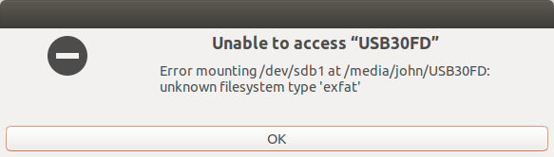

Fortunately, Samsung published a GPL driver for exFat so Linux users can share data with the other operating systems which support it such as Windows 10 and MacOS.

To demonstrate how to install the necessary packages in order to access the exFat drive, consider the image below, which shows a 63gb USB drive with the Ubuntu Disks application.

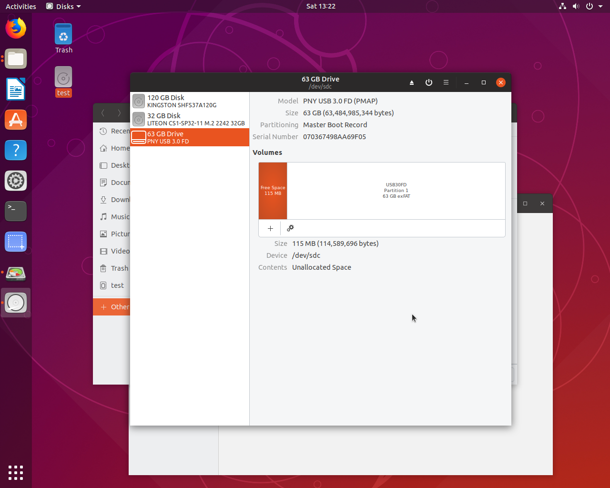

From the command line, you will need to make sure the proper repository, in this case, the universe repository, is installed. To ensure that the repository is installed, the add-apt command can be used. In the example below, the output of the add-apt command establishes that the repository is already present on the system. However, if it was not, the add-apt command could be used to install it:

**sysadmin@localhost:~$** sudo add-apt-repository universe

[sudo] password for sysadmin:

'universe' distribution component is already enabled for all sources.

**Note**

A *repository* is a collection of data stored on a server. In Linux, repositories are used to store system updates and applications that can be downloaded.

The add-apt command is part of the Advanced Package Tool (APT) used for package management.

*Repositories and package management are covered in greater detail later in the course.*

Next, the apt update command can be used to confirm that everything in the repository is up-to-date:

**sysadmin@localhost:~$** sudo apt update

Hit:1 http://us.archive.ubuntu.com/ubuntu cosmic InRelease

Get:2 http://us.archive.ubuntu.com/ubuntu cosmic-updates InRelease [88.7 kB]

Get:3 http://us.archive.ubuntu.com/ubuntu cosmic-security InRelease [88.7 kB]

Hit 4: http://us.archive.ubuntu.com/ubuntu cosmic-backports InRelease

Fetched 177 kB in 1s (139 kB/s)

Reading package lists… Done

Building dependency tree

Reading state information… Done

11 packages can be upgraded. Run ‘apt list —upgradable’ to see them.

Next, the needed exfat-fuse and exfat-utils packages will need to be installed using the apt install command.

Lastly, mount the drive (this step can also be done from the file manager).

